Ujamaa Place Salesforce Gift Entry Instructions

Instructions:
- Review training video for creating Contacts or Accounts
- Complete the initial navigation steps
- Select the closest description of the gift type from the headers below
- Complete the instructions for that section

Initial Navigation

Step #1: Go to www.salesforce.com and log in to your account. Ensure you are in Lightning Experience in order to match the screenshots below. If you aren’t click on the “Switch the Lightning Experience” button:

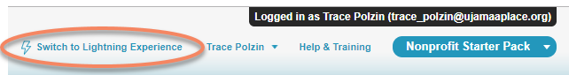

Step #2: Ensure that you are in the “Ujamaa Place” App in order to match the screenshots. If not click on the little keypad icon on the top left and switch to Ujamaa Place.

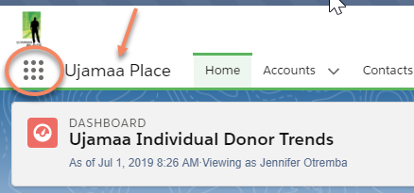

Step #3: Search for the Contact or Account (if it’s an organization or household) for whom you want to enter a donation. IMPORTANT: If the gift is from an individual but via a 3rd party (family fund, GiveMN, etc) do a search for that entity as well to be sure it’s in the database. If it’s not, add a new Account before moving to the next steps.

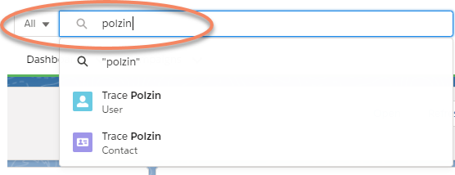

Step #4: Select the Contact or Account record. Note: If you are entering an individual/household gift we will enter the gift through the Household Account so if you navigate to the Contact first then you will need to navigate to the Account Name once you are there.
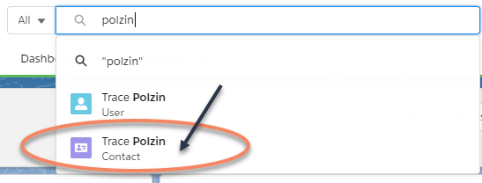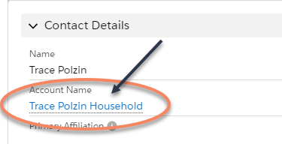

Step #5: Once you are on the relevant Account record, scroll until you see the “Donations” related list on the right.

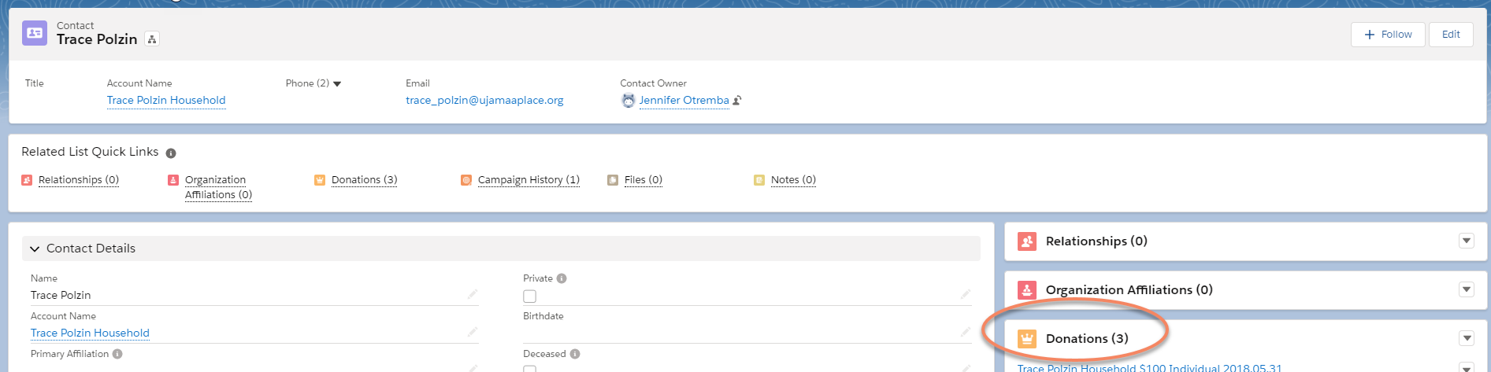

Step #6: Determine the specific type of Donation and complete the steps under the appropriate header below. If you are not sure of the donation type you have two options: 1) Consult with the Development office leadership, or 2) Make your best guess and then it can be modified during the monthly reconcile, if needed.

Donation from an Individual/Household via their personal checking account (or cash)

Begin by completing Steps #1-6 in the section above, then….

Step #7: After clicking “New” select “Individual” from the Donations dropdown menu. This will ensure that the Donation Record Type is correct and will bring up a screen specific to entering that kind of donation.

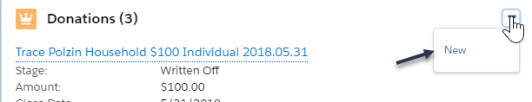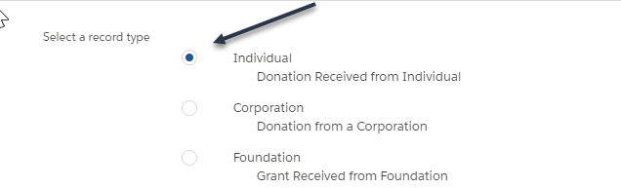

Step #8: Complete the following fields on the donation record according to the instructions (LEAVE ALL OTHER FIELDS BESIDES THESE BLANK)
- Opportunity Name = Salesforce populates this automatically but it’s a required field, so simply put an “X” in this field.
- Amount = Total amount of the check or cash payment
- Close Date = The date the check was received by Ujamaa, noted on the Deposit Tracking Form
- Description: Record any notes about the gift that may be helpful during the monthly reconcile, or to anyone revisiting the gift in the future.
- Payment Type = Select the correct payment type
- Accountant Coding = This should match with how you anticipate CLA will code this gift. This coding is then used to do a monthly reconcile between Salesforce and Quickbooks. If you are unsure, make your best guess and it can get resolved in the monthly reconcile as needed. The most common value is “Individual Unrestricted” for this type of gift.
- Year for Dev Recognition = Select this calendar year
- Primary Campaign Source: If this gift is tied with a Campaign, such as the Ask Breakfast or Year-End letter, select the magnifying glass to search for the Campaign name and then choose one.
- Stage = Select “Received”
- Honoree Name: Complete if applicable as this will impact TY letter processes.
- Acknowledgement Letter: For a typical individual gift this should be “IRS – General”

Step #9: Once all relevant fields are populated, be sure to SAVE the record.

Step #10: If the gift was a check, the check number needs to be recorded. To do that first ensure that you are on the Donation record by looking at the label on the top left of the white area of the screen.

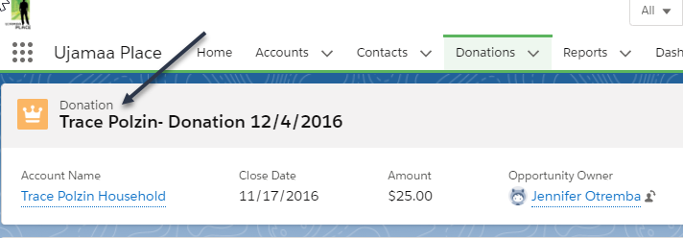

Step #11: Scroll down on the Donation record until you locate the “Payments” object.

Step #12: click on the PMT record name. Once inside, enter the check number on the “Check Number” field and select “Check for payment type.” Be sure to SAVE the Payment record.

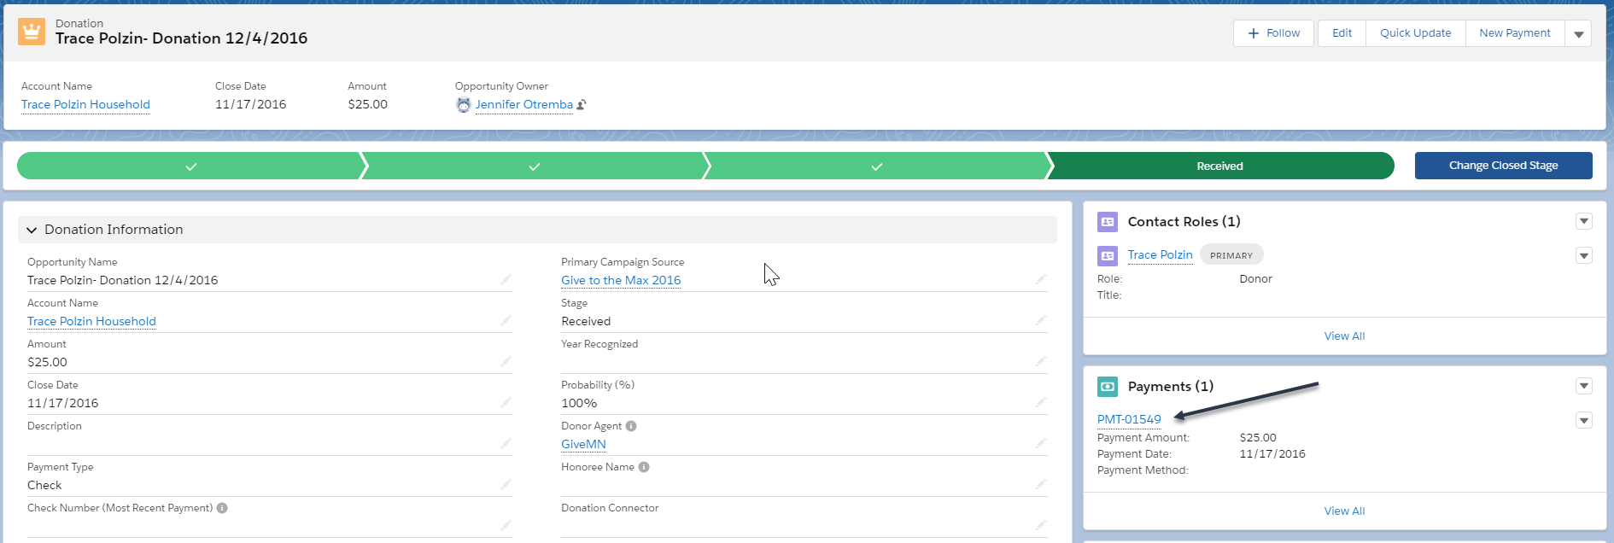

Donation from an individual/household via a family fund or payment processor
(Ex: Smith Family Fund, Schwab Charitable, GiveMN, Truist, etc)

Begin by completing Steps #1-6 in the section above, then….

Step #7: After clicking “New” select “Household Gift via Donor Agent” from the dropdown menu. This will ensure that the Donation Record Type is correct and will bring up a screen specific to entering that kind of donation.

Step #8: Complete the following fields on the donation record according to the instructions:
- Opportunity Name = Salesforce populates this automatically but it’s a required field, so simply put an “X” in this field.
- Amount = Total amount of the check or cash payment
- Close Date = The date the check was received by Ujamaa, noted on the Deposit Tracking Form
- Description: Record any notes about the gift that may be helpful during the monthly reconcile, or to anyone revisiting the gift in the future.
- Payment Type = Select the correct payment type
- Accountant Coding = This should match with how you anticipate CLA will code this gift. This coding is then used to do a monthly reconcile between Salesforce and Quickbooks. If you are unsure, make your best guess and it can get resolved in the monthly reconcile as needed. The most common value is “Individual Unrestricted” for this type of gift.
- Year for Dev Recognition = Select this calendar year
- Primary Campaign Source: If this gift is tied with a Campaign, such as the Ask Breakfast or Year-End letter, select the magnifying glass to search for the Campaign name and then choose one.
- Stage = Select “Received”
- Honoree Name: Complete if applicable as this will impact TY letter processes.
- Acknowledgement Letter: For a typical individual gift this should be “NonIRS – General”
- Donor Agent: This is the field where you will need to link to the Donation to the agent through which it was processed. Click the magnifying glass to search for the Account
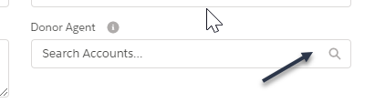
Once you locate the Donor Agent Account name, select it from the list. Note: If the Account name is not listed you likely missed the step in the section above to add the Account. Pause here and go add the Account.
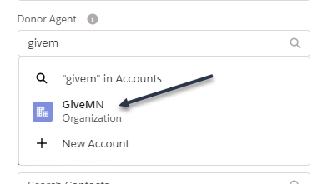

Step #9: Once all relevant fields are populated, be sure to SAVE the record.

Step #10: If the gift was a check, the check number needs to be recorded. To do that first ensure that you are on the Donation record by looking at the label on the top left of the white area of the screen.

Step #11: Scroll down on the Donation record until you locate the “Payments” object.

Step #12: click on the PMT record name. Once inside, enter the check number on the “Check Number” field and select “Check for payment type.” Be sure to SAVE the Payment record.

Donation from an Organization (Foundation, Corporate, Government)

Begin by completing Steps #1-6 in the section above, then….

Step #7: After clicking “New” select either “Foundation/Corporate/Government” from the dropdown menu. This will ensure that the Donation Record Type is correct and will bring up a screen specific to entering that kind of donation.

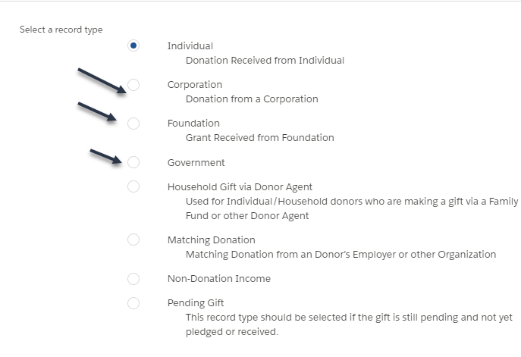

Step #8: Complete the following fields on the donation record according to the instructions:
- Opportunity Name = Salesforce populates this automatically but it’s a required field, so simply put an “X” in this field.
- Amount = Total amount of the check or cash payment
- Close Date = The date the check was received by Ujamaa, noted on the Deposit Tracking Form
- Description: Record any notes about the gift that may be helpful during the monthly reconcile, or to anyone revisiting the gift in the future.
- Payment Type = Select the correct payment type
- Accountant Coding = This should match with how you anticipate CLA will code this gift. This coding is then used to do a monthly reconcile between Salesforce and Quickbooks. If you are unsure, make your best guess and it can get resolved in the monthly reconcile as needed. The most common value is “Foundation Unrestricted” or “Corporate Unrestricted” for this type of gift.
- Year for Dev Recognition = Select this calendar year
- Primary Campaign Source: If this gift is tied with a Campaign, such as the Ask Breakfast or Year-End letter, select the magnifying glass to search for the Campaign name and then choose one.
- Stage = Select “Received”
- Honoree Name: Complete if applicable as this will impact TY letter processes.
- Acknowledgement Letter: For a typical organizational gift this should be “IRS – General”

Step #9: Once all relevant fields are populated, be sure to SAVE the record.

Step #10: If the gift was a check, the check number needs to be recorded. To do that first ensure that you are on the Donation record by looking at the label on the top left of the white area of the screen.

Step #11: Scroll down on the Donation record until you locate the “Payments” object.

Step #12: click on the PMT record name. Once inside, enter the check number on the “Check Number” field and select “Check for payment type.” Be sure to SAVE the Payment record.

Pledge from an Individual/Household

Begin by completing Steps #1-6 in the section above, then….
Complete the steps for “Donation from an Individual/Household via their personal checking account (or cash)”

EXCEPT the following fields should be completed differently for pledges:

- Stage = Select “Pledged”
- **Do Not Automatically Create Payment: Check this box. It will prevent the system from creating a “dummy” payment for the pledge. Payments will then be entered as they are received.
- Once all relevant fields are populated, be sure to SAVE the record.

Pledge from an individual/household via a family fund or payment processor
(Ex: Smith Family Fund, Schwab Charitable, GiveMN, Truist, etc)

Begin by completing Steps #1-6 in the section above, then….
Complete the steps for “Donation from an individual/household via a family fund or payment processor”

EXCEPT the following fields should be completed differently for pledges:

- Stage = Select “Pledged”
- **Do Not Automatically Create Payment: Check this box. It will prevent the system from creating a “dummy” payment for the pledge. Payments will then be entered as they are received.
- Once all relevant fields are populated, be sure to SAVE the record.

Pledge from an Organization

Begin by completing Steps #1-6 in the section above, then….
Complete the steps for “Donation from Organization (Foundation, Corporate,Government”

EXCEPT the following fields should be completed differently for pledges:

- Stage = Select “Pledged”
- **Do Not Automatically Create Payment: Check this box. It will prevent the system from creating a “dummy” payment for the pledge. Payments will then be entered as they are received.
- Once all relevant fields are populated, be sure to SAVE the record.

